loveable chats:
me:
You are an expert AI email writing assistant. Your task is to generate a professional email based on the user's input.
User Input:
Recipient: [user recipient]
Purpose: [user_purpose]
Key Points: [user_key_points]
Desired Tone: [user_tone]
Instructions:
1. Generate a complete email with a clear subject line.
2. Use the specified tone consistently throughout the email.
3. Ensure all key points are woven into the email naturally.
4. Conclude with a polite and appropriate signoff.

Build a modern, responsive web application called "AI Workplace Productivity Assistant" that helps professionals automate workplace tasks using AI.

The application should include these 5 features accessible via a sidebar:

1. Smart Email Generator
2. Meeting Notes Summarizer
3. AI Task Planner
4. AI Research Assistant
5. AI Chatbot Interface

Requirements:
Modern SaaSstyle dashboard UI with a clean, professional color scheme
Sidebar navigation with icons for each feature
Responsive design (works on desktop and mobile)
Each feature page has a clear INPUT section and OUTPUT section
AI outputs should be displayed in editable text areas
A persistent Responsible AI disclaimer in the footer
Use shading/ui components and Tailwind CSS
Add a welcome/dashboard home page that introduces the app

Make the sidebar dark navy blue with white text and a subtle hover effect on links.
On the Email Generator page, add a dropdown for "Tone" with options: Formal, Friendly, Persuasive, Apologetic, Direct.
Make sure every page has a consistent header with the tool name and a short description.
Add a small info icon next to each tool that shows a tooltip explaining what the AI does.

AI: Got it — I'm building the workspace now and will include the navy sidebar, tone dropdown, consistent page headers, and info tooltips in this build.
Your AI Workplace Productivity Assistant is ready. It has a welcome dashboard and all five tools, each with an input side and an output side you can edit.

Your latest requests are all in:
The sidebar is dark navy with white text and a soft highlight when you point at a link.
The Email Generator has a Tone dropdown: Formal, Friendly, Persuasive, Apologetic or Direct.
Every page opens with the same header showing the tool name and a short description.
Each tool has a small info icon. Hover over it to see what the AI does.
The Responsible AI notice stays visible at the bottom of every page.

I tested the Email Generator, and it wrote a real email. I haven't tested the chatbot yet. It only works after you sign in, because your conversation is saved privately to your account. You can sign in with email or Google, and a "Clear chat" button lets you start over.

To try it, open the Chatbot page, sign in and send a message.
me: Connect the Email Generator's "Generate" button to an AI model. When clicked, send the form inputs to the AI using this prompt structure: [paste your structured prompt from the walkthrough]. Display the response in the output text area.
AI: The Generate button is already connected to AI. When you click it, it sends the recipient, tone, purpose and key points to the AI, and the reply shows up in the output box where you can edit it. I tested it and it wrote a full email.
me: continue with google sign in is not working
AI: I fixed "Continue with Google". Google signing has been switched back on, and once you pick your Google account you'll go straight to the Chat page. If something goes wrong, you'll now see the actual reason on screen instead of a general error.
Me: The email sign in function works and all other functions are functional, thank you.
Testing meeting notes summarizer:
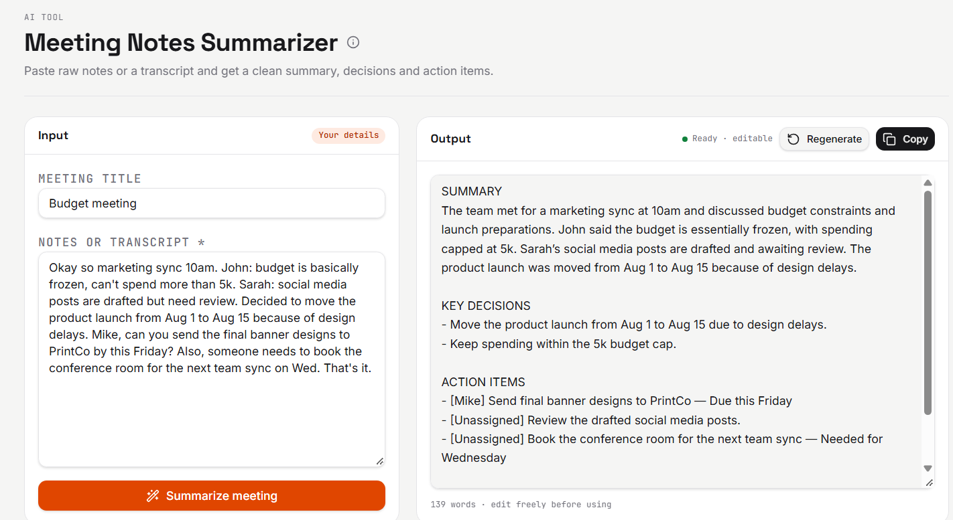
Output:
SUMMARY
The team met for a marketing sync at 10am and discussed budget constraints and launch preparations. John said the budget is essentially frozen, with spending capped at 5k. Sarah’s social media posts are drafted and awaiting review. The product launch was moved from Aug 1 to Aug 15 because of design delays.

KEY DECISIONS
- Move the product launch from Aug 1 to Aug 15 due to design delays.
- Keep spending within the 5k budget cap.

ACTION ITEMS
- [Mike] Send final banner designs to PrintCo — Due this Friday
- [Unassigned] Review the drafted social media posts.
- [Unassigned] Book the conference room for the next team sync — Needed for Wednesday

OPEN QUESTIONS
- Who will review the social media posts, and by when?
- Who will book the conference room for Wednesday’s team sync?

AI task planner:
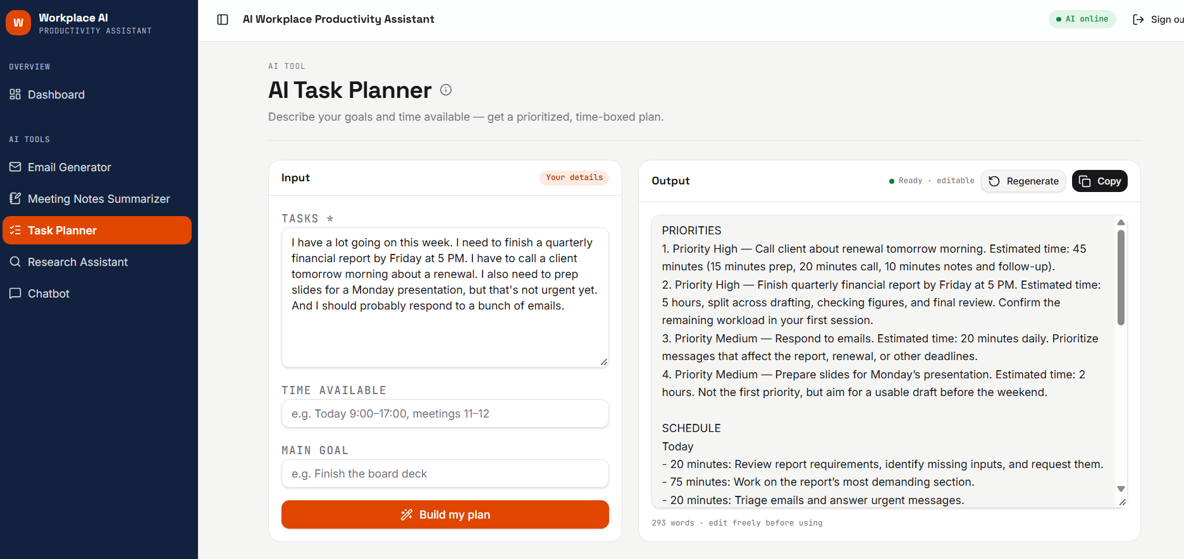
Output:
PRIORITIES
1. Priority High — Call client about renewal tomorrow morning. Estimated time: 45 minutes (15 minutes prep, 20 minutes call, 10 minutes notes and follow-up).
2. Priority High — Finish quarterly financial report by Friday at 5 PM. Estimated time: 5 hours, split across drafting, checking figures, and final review. Confirm the remaining workload in your first session.
3. Priority Medium — Respond to emails. Estimated time: 20 minutes daily. Prioritize messages that affect the report, renewal, or other deadlines.
4. Priority Medium — Prepare slides for Monday’s presentation. Estimated time: 2 hours. Not the first priority, but aim for a usable draft before the weekend.

SCHEDULE
Today
- 20 minutes: Review report requirements, identify missing inputs, and request them.
- 75 minutes: Work on the report’s most demanding section.
- 20 minutes: Triage emails and answer urgent messages.

Tomorrow morning
- First available morning slot, ideally at an agreed client time: 45 minutes for renewal prep, call, and follow-up.
- Next uninterrupted block: 75 minutes on the report.

Before Friday afternoon
- 90 minutes: Complete the report draft and check figures.
- 60 minutes: Outline the presentation and draft key slides.
- 20 minutes daily: Process priority emails.

Friday
- 2:00–2:40 PM: Final report review and formatting.
- 2:40–3:00 PM: Submit the report, leaving two hours before the deadline.
- 3:00–4:00 PM: Finish a usable slide draft. Move this block if the report needs the buffer.

Monday
- 20–30 minutes before the presentation: Rehearse and check the slides.

TIPS
- Protect report blocks from email and notifications.
- If fewer days remain than this plan assumes, combine report blocks and postpone nonessential email.
- Keep slide design simple until the report is submitted; focus first on the message and supporting evidence.

Research assistant:

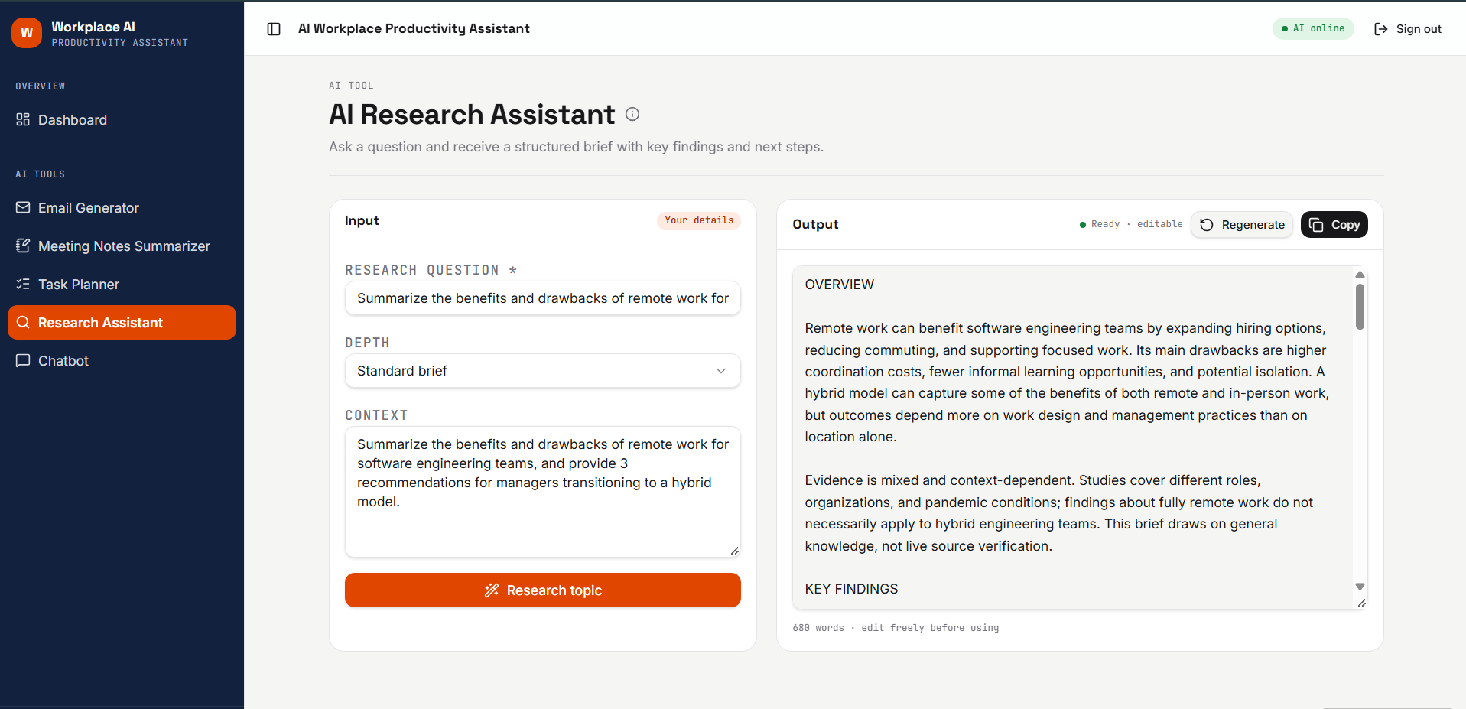
Output:
OVERVIEW
Remote work can benefit software engineering teams by expanding hiring options, reducing commuting, and supporting focused work. Its main drawbacks are higher coordination costs, fewer informal learning opportunities, and potential isolation. A hybrid model can capture some of the benefits of both remote and in-person work, but outcomes depend more on work design and management practices than on location alone.

Evidence is mixed and context-dependent. Studies cover different roles, organizations, and pandemic conditions; findings about fully remote work do not necessarily apply to hybrid engineering teams. This brief draws on general knowledge, not live source verification.

KEY FINDINGS

Benefits
- Focus and flexibility: Fewer office interruptions and more control over schedules can help with coding, debugging, and design work. Benefits depend on the home environment and meeting load.
- Broader talent access: Remote hiring expands the candidate pool beyond commuting distance and may improve access for people with disabilities or caregiving responsibilities.
- Retention and satisfaction: Flexibility and reduced commuting can improve employee satisfaction and help retain engineers who value location autonomy.
- Better written knowledge: Remote collaboration encourages documentation, recorded decisions, and asynchronous reviews, making knowledge less dependent on who is present.
- Potential cost savings: Employees may save commuting costs, while organizations may reduce office expenses. Hybrid arrangements do not guarantee savings if full office capacity is retained.

Drawbacks
- Coordination overhead: Time-zone differences and asynchronous exchanges can delay clarification, code reviews, and incident handoffs.
- Harder onboarding and mentoring: Junior engineers and new hires may have fewer opportunities to observe experienced colleagues or ask spontaneous questions.
- Weaker informal connections: Reduced casual interaction can make trust-building, cross-team collaboration, and early conflict resolution harder.
- Isolation and blurred boundaries: Some employees experience loneliness, longer working hours, or pressure to remain constantly available.
- Unequal working conditions: Home space, connectivity, accessibility, and secure equipment vary across employees. Hybrid meetings can also disadvantage remote participants.

CONSIDERATIONS & RISKS

Productivity is difficult to measure. Commits, lines of code, and online activity are weak standalone indicators of engineering value. Assess delivery alongside reliability, maintainability, customer outcomes, and team well-being.

Effects vary by task and team. Established teams doing relatively independent work may adapt more easily than newly formed teams handling ambiguous, tightly coupled projects. Onboarding, architectural decisions, and sensitive discussions may benefit from deliberate real-time interaction, whether online or in person.

Hybrid work creates a particular risk of proximity bias: employees in the office may receive more visibility, information, or advancement opportunities. Poorly coordinated attendance can also produce commuting without meaningful face-to-face collaboration.

Security, employment law, tax obligations, and data-access restrictions can complicate work across jurisdictions. These require organization- and location-specific review.

SUGGESTED NEXT STEPS

1. Establish a remote-accessible operating agreement.
Define core overlap hours, response expectations, review turnaround targets, and incident escalation paths. Use shared documents and decision logs as the authoritative record. Make hybrid meetings accessible to everyone, with clear agendas and written outcomes.

2. Make in-person time purposeful and equitable.
Coordinate attendance around activities that benefit from interaction, such as onboarding, planning, design workshops, and relationship-building. Preserve focused work time. Provide structured mentoring and regular check-ins, and evaluate performance by contribution rather than office visibility.

3. Pilot the model and measure outcomes.
Run a time-bounded pilot, for example 8–12 weeks, using a pre-pilot baseline. Track a small, balanced set of team-level measures: delivery lead time, review delays, defects or incidents, and employee feedback on focus, inclusion, and workload. Adjust based on results; short pilots cannot reliably establish long-term retention or career-development effects.

SOURCES TO VERIFY

- Peer-reviewed studies in software engineering, organizational psychology, and management, especially studies distinguishing remote from hybrid work.
- Randomized or longitudinal workplace studies, checking whether findings apply specifically to software engineers.
- DORA research on software delivery performance and team practices, noting the limitations of correlational evidence.
- Developer surveys from established professional organizations and research groups, checking sampling methods and self-report bias.
- Government labor statistics and official employment, tax, and cybersecurity guidance for relevant jurisdictions.
- Internal delivery data and confidential employee surveys, interpreted alongside staffing, project complexity, and organizational changes.

AI Chat bot:
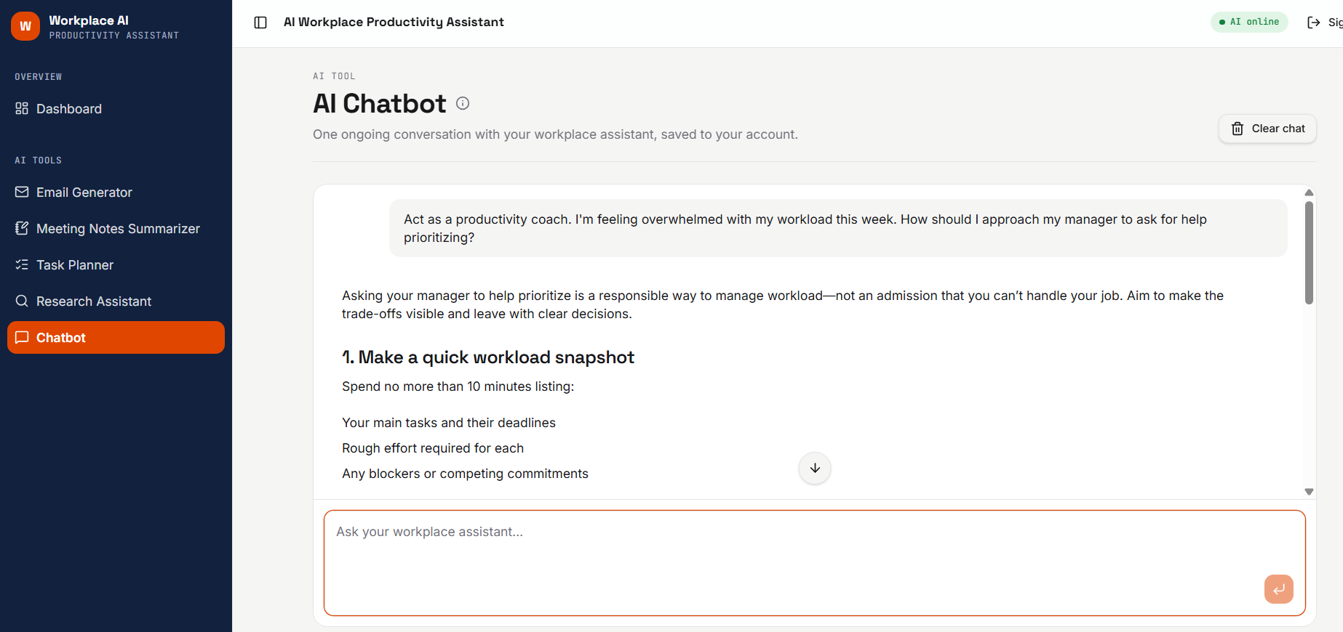
Output:
Asking your manager to help prioritize is a responsible way to manage workload—not an admission that you can’t handle your job. Aim to make the trade-offs visible and leave with clear decisions.
1. Make a quick workload snapshot
Spend no more than 10 minutes listing:
- Your main tasks and their deadlines
- Rough effort required for each
- Any blockers or competing commitments
Mark what you think should come first so your manager has a starting point.
2. Request a short prioritization conversation
You could send:
“Could we spend 15 minutes reviewing my priorities for this week? I have several competing deadlines, and I want to make sure I’m focusing on the most important work. I’ll bring a short list and a proposed order.”
3. Ask for specific trade-offs
In the meeting, describe the capacity gap plainly:
“I’m feeling stretched by the current workload. Given the time available, I can complete A and B this week, but C would need more time or support. My recommendation is to prioritize A, then B. Does that match your expectations?”
Then ask:
- “What must be completed this week?”
- “What can move, be reduced in scope, or be reassigned?”
- “If a new urgent request comes in, which existing priority should it replace?”
If everything is labeled urgent, try: “What should I work on first, and which deadline should we adjust to make that possible?”
4. Confirm the plan
Send a brief recap: “Agreed: A first, B by Friday, and C moved to next week. I’ll flag any changes that put those commitments at risk.”
You don’t need to prove you’re overwhelmed. The goal is to get alignment on what’s achievable—and what won’t get done without a change.
Sign in test:
